**WEB APPLICATION DEVELOPMENT**

**ASSIGNMENT**

SHOPPING REGISTRATION FORM

CODE:

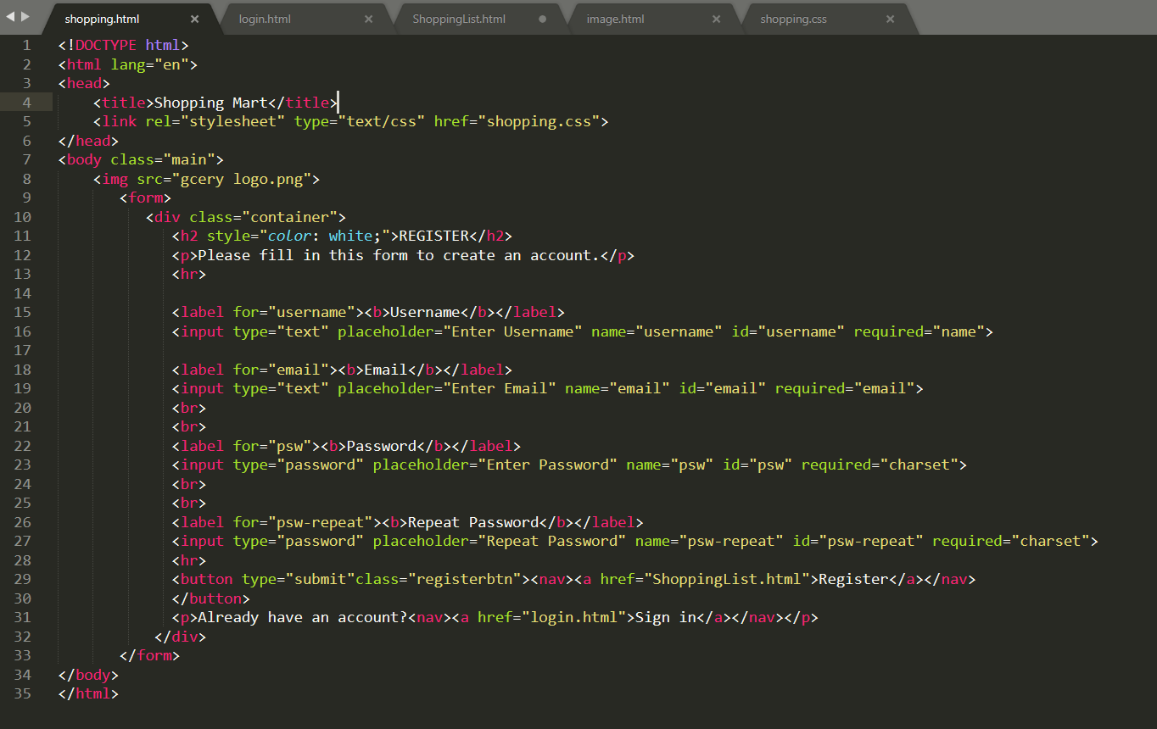

OUTPUT:

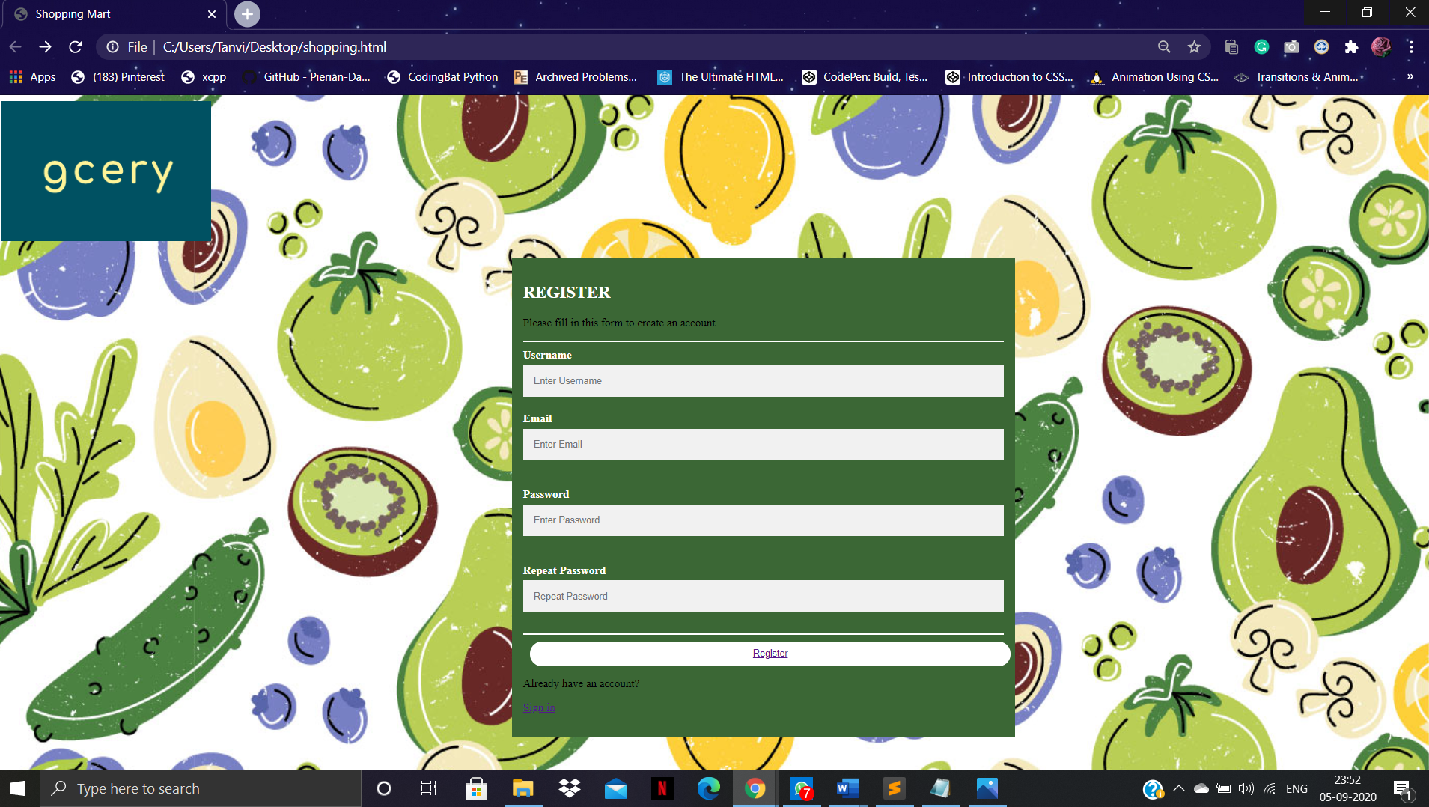

SHOPPING LOGIN FORM:

CODE:

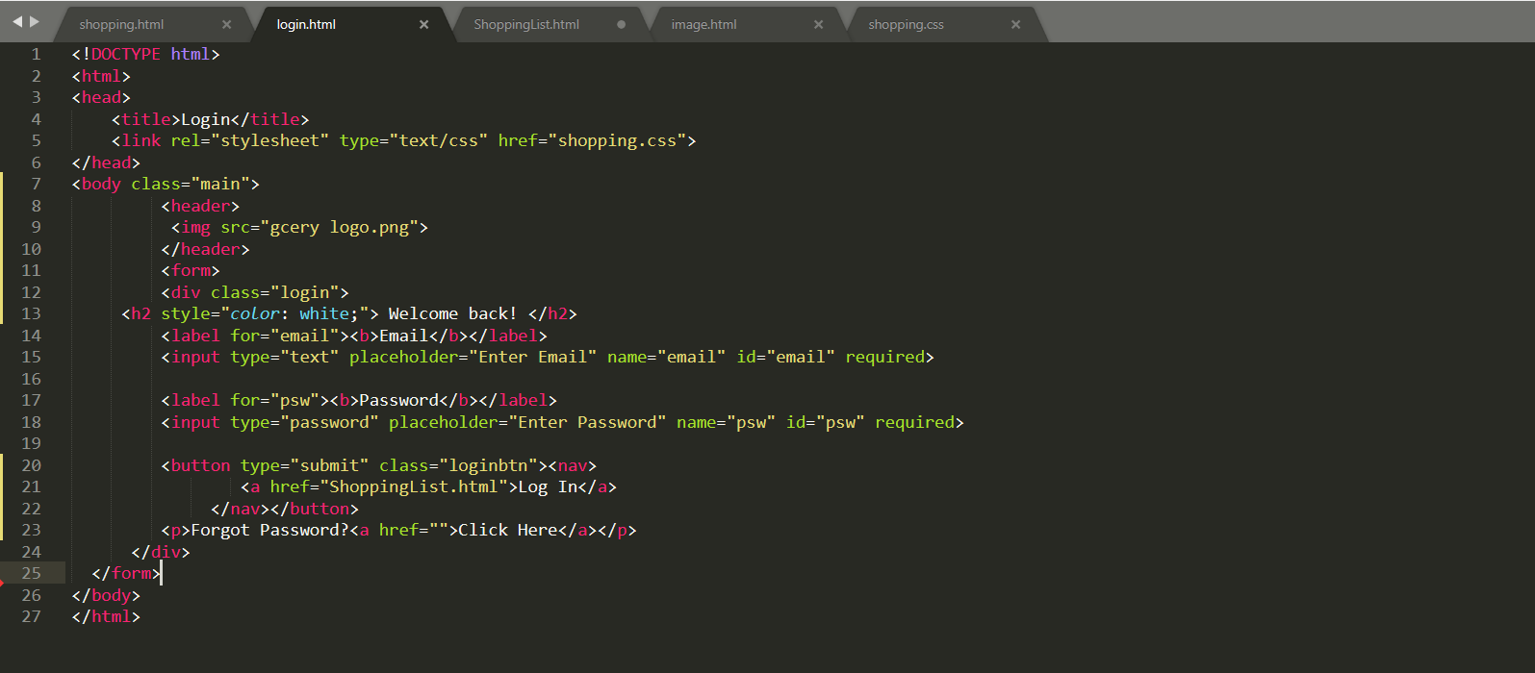

OUTPUT:

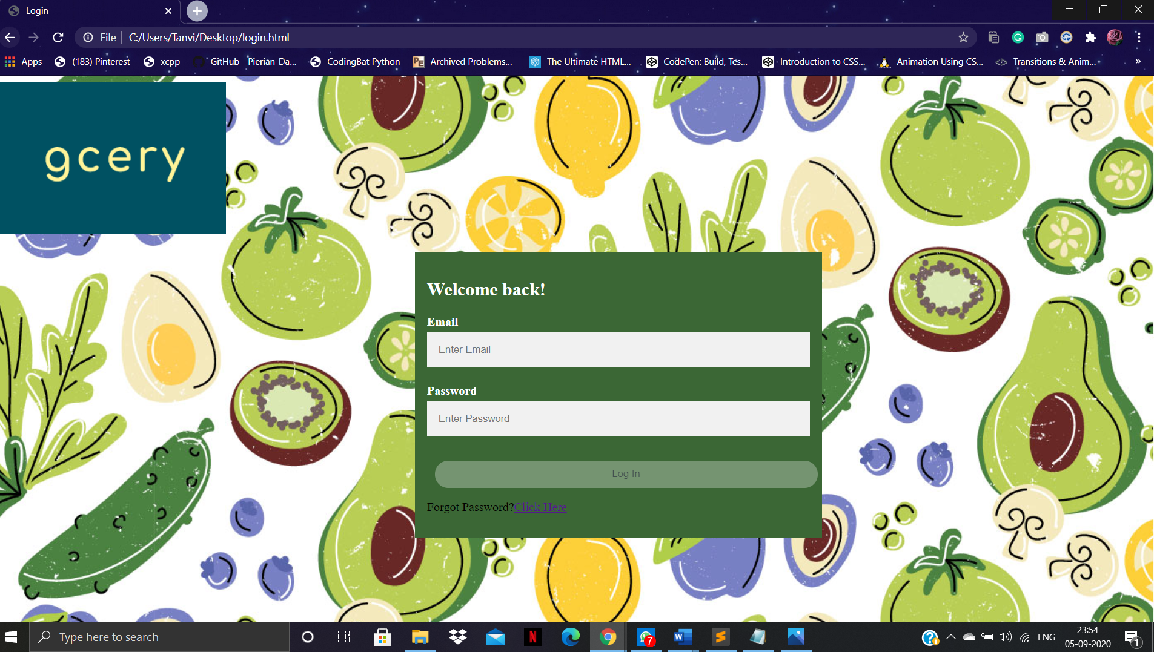

SHOPPING LIST:

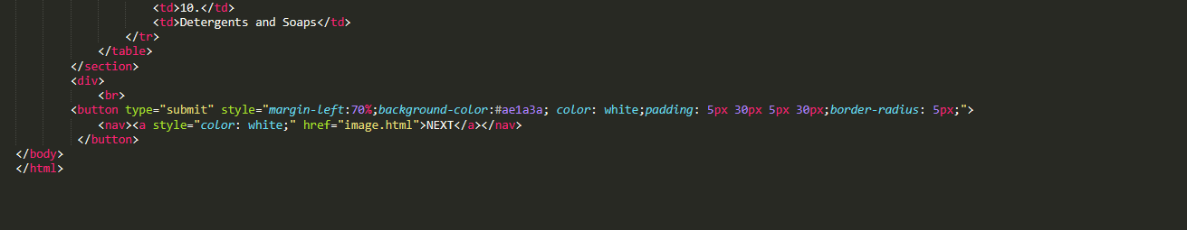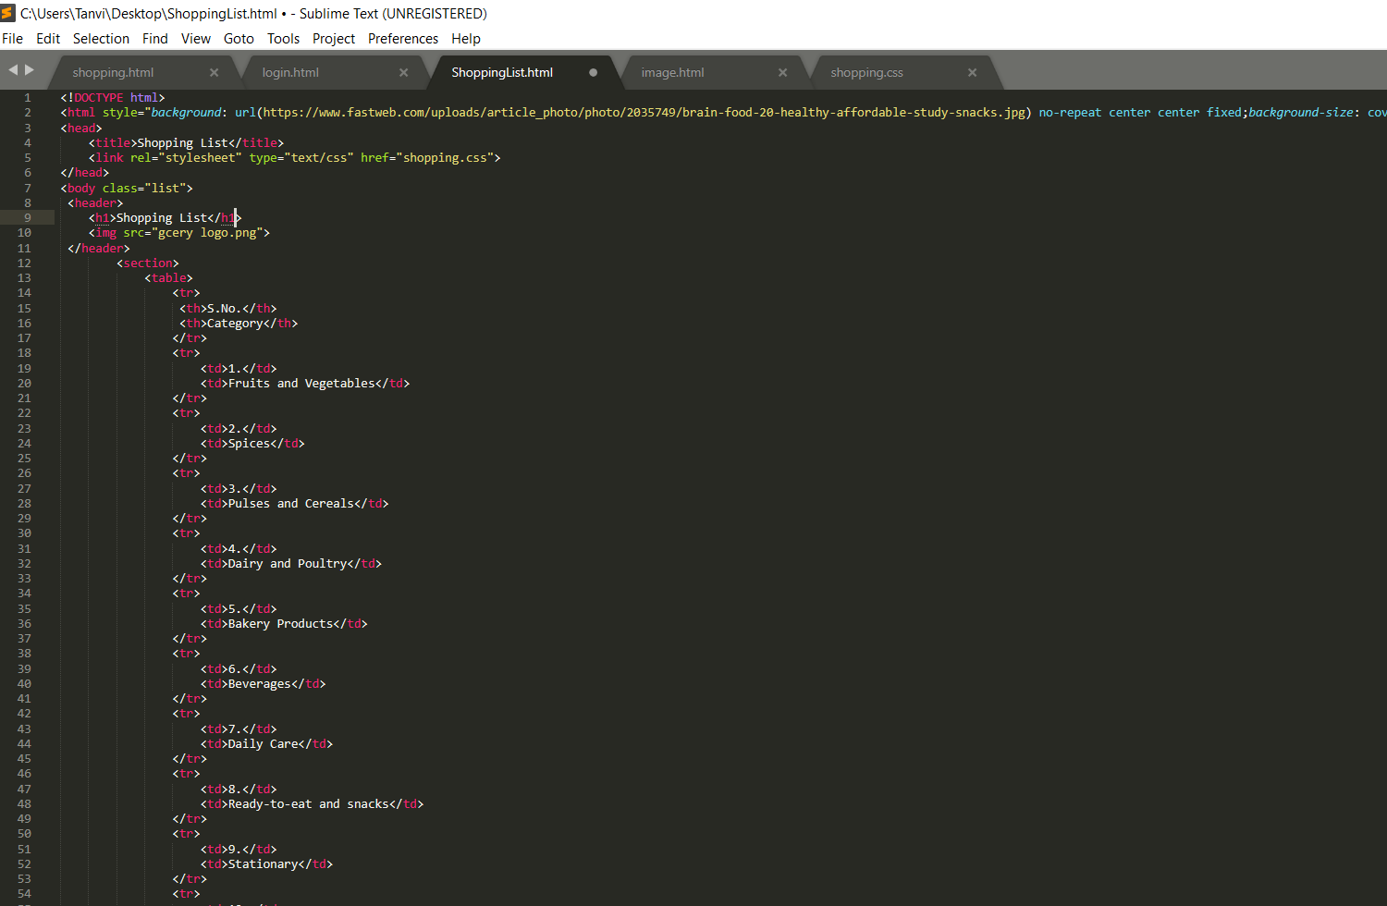

OUTPUT: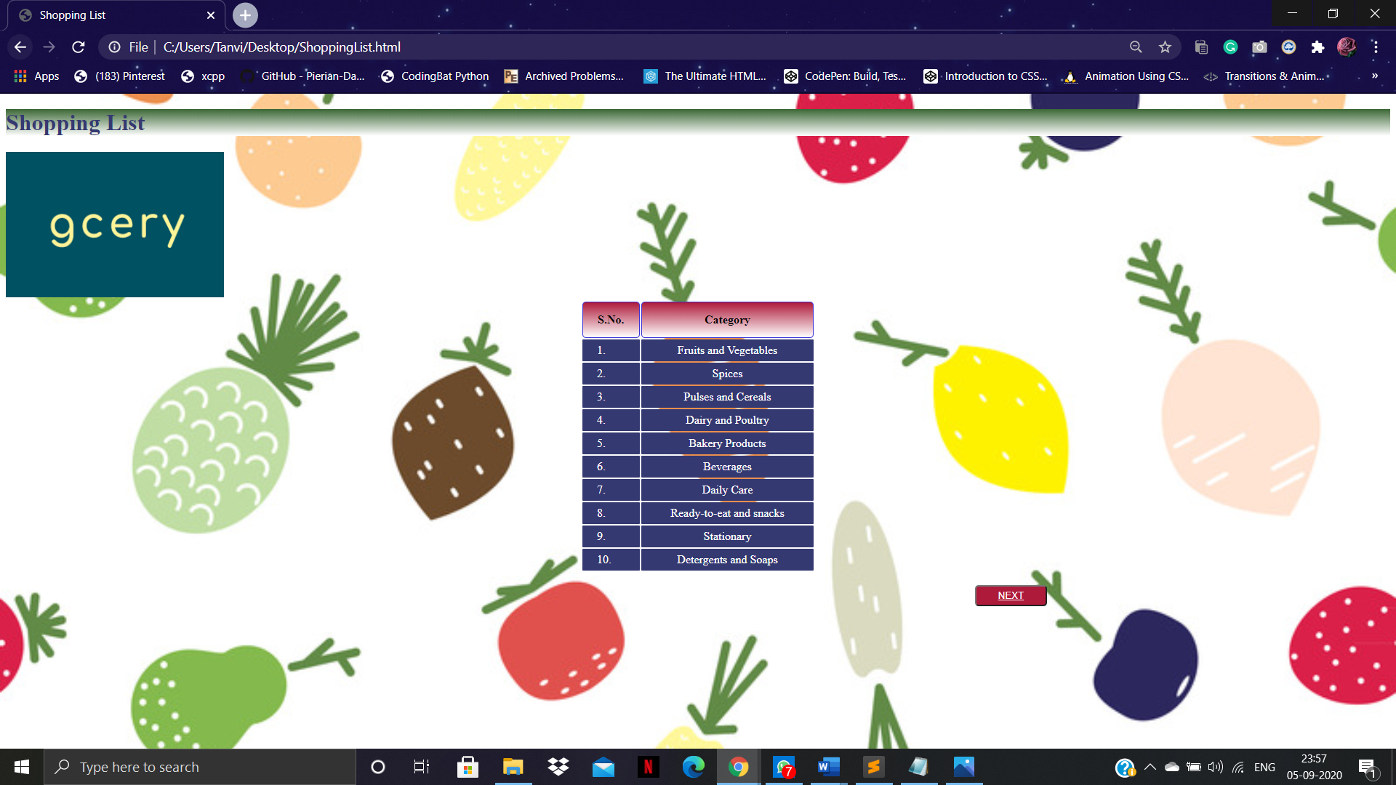

IMAGE FILE:

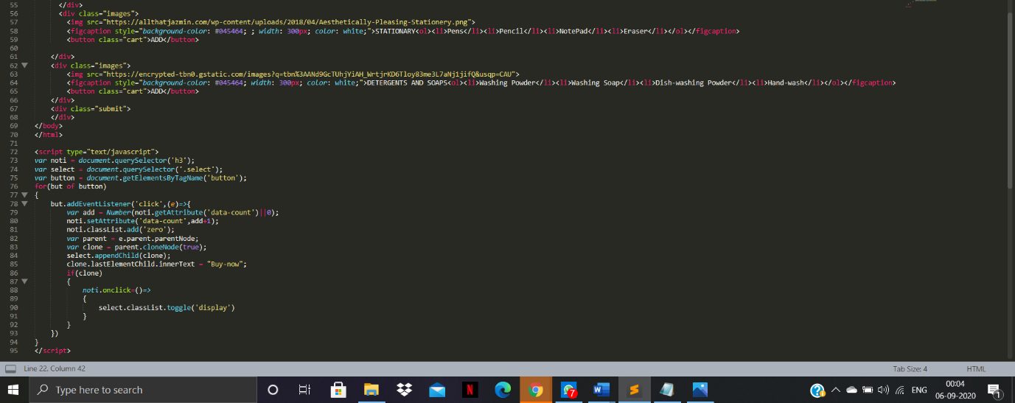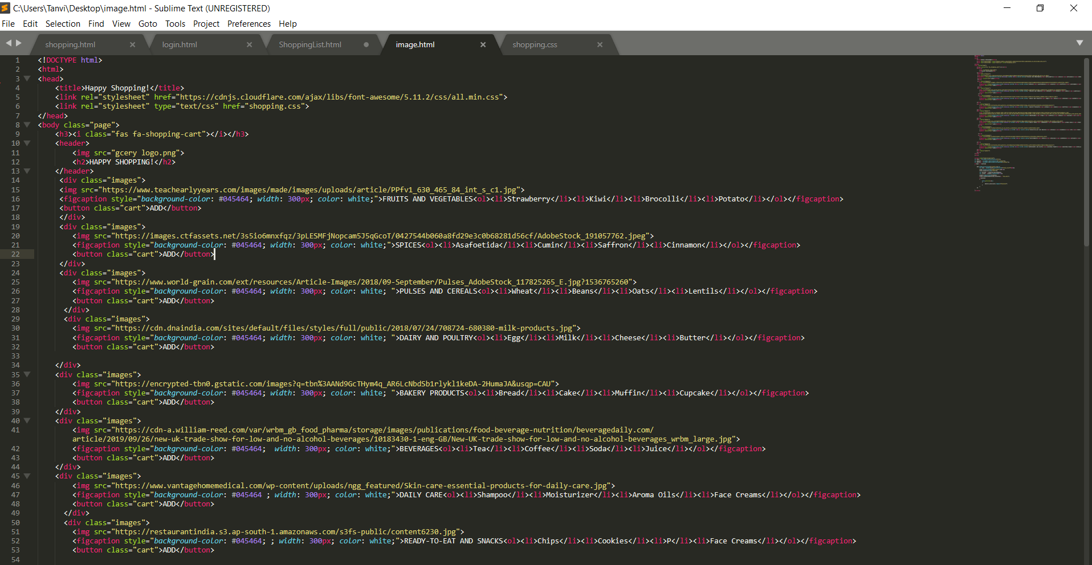

OUTPUT: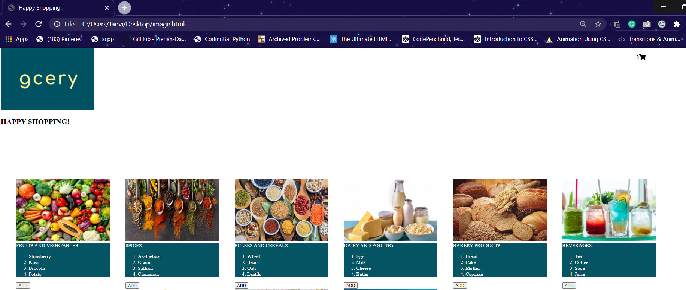

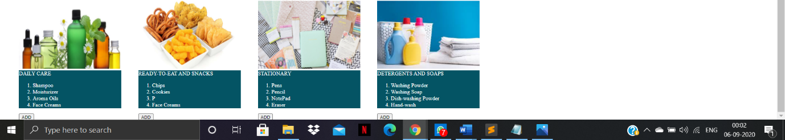

CSS FILE:

